EVALUATION
DOCATHOME:AIDoctorChatbot

Project Based Learning –V

Submitted by

Prachi
(2310993902)
Amrit Kaur
(2310993773)
Akansha
(2310993769)
Semester: 5



BE-CSE (Artificial Intelligence)

Submitted To
Dr. Harshvardhan
Assistant Professor, Department of CSE(AI),
CUIET, Chitkara University

CHITKARA UNIVERSITY INSITUTE OF ENGINEERING & TECHNOLOGY
CHITKARA UNIVERSITY, RAJPURA
May- 2025

Table of Contents
Serial No. Title Page No.
1. Introduction 5
2. Flowchart 6-7
3. Methodology 8-9
4. Tools and Technologies 10-11
5. Code (Python File) 11-18
6. Major Findings/Output/Results 19
7. Result 20-21
8. Conclusion and Future Scope 22-23
9. References 24

ACKNOWLEDGEMENT

With immense pleasure We, Ms.Prachi , Ms.Amrit & Ms. Akansha presenting the “DOCATHOME:AIDoctorChatbot” project report as part of the curriculum of ‘BE-CSE (AI)’.
I would like to express my sincere thanks to Dr. Harshvardhan for their valuable guidance and support in completing my project.
I would also like to express my gratitude towards our dean Dr. Sushil Kumar Narang for giving me this great opportunity to do a project on this website. Without their support and suggestions, this project would not have been completed.

Signature……….
Name: Prachi
Roll No: 2310993902
Signature……….
Name: Amrit
Roll No:2310993773
Signature……….
Name: Akansha
Roll No:2310993769

ABSTRACT

This project presents Dr. AI Assistant, a local intelligent medical chatbot designed to assist radiologists and healthcare professionals in diagnostic case discussions. The system uses an agentic AI approach, combining autonomous agents for context management, memory handling, and medical response generation. A FLAN-T5 transformer model powers the reasoning process, enabling concise and medically relevant replies to user queries without requiring external APIs.

All chat data, including case histories and messages, are securely stored in a local JSON-based database, ensuring privacy and persistence. Users can create case-specific chat rooms, interact naturally with the AI assistant, and receive structured responses tailored to each case. The chatbot is deployed through an intuitive Streamlit web interface, offering real-time interaction and reliable offline operation.

This system demonstrates the integration of agentic reasoning and local AI models to create a privacy-preserving, accessible, and context-aware AI medical consultation tool for clinical environments.

INTRODUCTION

Artificial Intelligence (AI) is increasingly transforming the field of healthcare by supporting diagnosis, treatment planning, and medical decision-making. However, many existing AI medical tools rely heavily on cloud-based APIs, raising concerns about data privacy, accessibility, and cost. To address these challenges, Dr. AI Assistant was developed — a local, agentic AI-powered chatbot designed to assist radiologists and medical professionals in case discussions and clinical reasoning.
The system utilizes a FLAN-T5 transformer model for generating intelligent, context-aware responses without depending on external services such as Gemini or OpenAI APIs. It is structured around agentic components that manage conversation flow, memory storage, and reasoning tasks autonomously. Each case discussion is stored securely in a local JSON database, ensuring full control over data.
Integrated with a Streamlit web interface, Dr. AI Assistant provides an intuitive platform for interactive medical dialogues, allowing users to ask case-specific questions and receive professional, concise, and medically reliable answers.

Flowchart

┌─────────────────────────────┐
│ Radiologist (User) │
│ Inputs medical query │
└──────────────┬──────────────┘
│
▼
┌─────────────────────────────┐
│ Streamlit Web Interface │
│ (Frontend for chat & cases) │
└──────────────┬──────────────┘
│
▼
┌─────────────────────────────┐
│ Conversation Manager Agent │
│ - Creates/loads chat room │
│ - Saves messages locally │
└──────────────┬──────────────┘
│
▼
┌─────────────────────────────┐
│ Reasoning Agent (FLAN-T5) │
│ - Processes query │
│ - Generates medical reply │
└──────────────┬──────────────┘
│
▼
┌─────────────────────────────┐
│ Response Handler │
│ - Cleans & formats answer │
│ - Adds to chat history │
└──────────────┬──────────────┘
│
▼
┌─────────────────────────────┐
│ Local JSON Storage │
│ - Stores case details │
│ - Maintains message logs │
└──────────────┬──────────────┘
│
▼
┌─────────────────────────────┐
│ Streamlit Display │
│ - Shows Dr. AI reply │
│ - Ready for next input │
└─────────────────────────────┘

Methodology

The development of the Dr. AI Assistant system follows a structured methodology comprising several integrated stages to ensure accurate, efficient, and context-aware medical interactions.
1. Data Handling and Storage
A lightweight JSON-based storage mechanism was implemented to locally save all conversation data. Each chat session or medical case is treated as an independent “room,” maintaining details such as user information, timestamps, and message history. This ensures privacy, traceability, and easy retrieval without requiring an external database.
2. Chat Room Management
The system dynamically creates and manages chat rooms using Python utility functions. Each room includes participants (Radiologist and Dr. AI Assistant) and automatically generates a welcome message. This modular setup allows multiple case discussions to occur independently and persistently.
3. Natural Language Understanding
For intelligent response generation, the system employs the FLAN-T5-Small transformer model from Hugging Face. This model functions as the Reasoning Agent, interpreting the radiologist’s queries and generating context-aware, medically relevant replies.
Hyperparameters such as beam search, temperature control, and repetition penalty are fine-tuned to improve factuality and reduce response repetition.
4. Agentic Architecture
Two key agents govern the workflow:
- Conversation Manager Agent – handles chat creation, message logging, and retrieval.
- Reasoning Agent (FLAN-T5) – processes user prompts, applies medical reasoning, and formulates concise responses.
This agentic design ensures modularity, making it easy to upgrade or integrate other models in the future.
5. Response Generation and Validation
The generated response is post-processed to remove redundancies (e.g., repeated prefixes or filler text) and formatted into a professional tone suitable for medical contexts. If the output is too short or incoherent, a fallback message prompts the user to rephrase the query, ensuring stable system behavior.
6. User Interaction via Streamlit
A Streamlit-based interface serves as the user front-end. It allows radiologists to:
- Create or select cases,
- Ask medical questions,
- View Dr. AI’s structured responses in real-time.
This design ensures simplicity, accessibility, and real-time responsiveness.
7. Local Execution and Privacy
All operations — including model inference and data storage — occur locally. No cloud-based APIs are required, ensuring data security, low latency, and offline functionality, which are critical for healthcare applications.

Tools and Technologies

1. Programming Language
Python 3.10+
Used as the core language for implementing the backend logic, model integration, and data handling due to its rich ecosystem for AI, machine learning, and web applications.
2. Framework
Streamlit
Provides a user-friendly and interactive web interface for real-time doctor–AI communication. It enables dynamic chat components, file uploads, and visualization within a browser without complex frontend development.
3. Natural Language Processing Model
FLAN-T5-Small (Hugging Face Transformers)
- A fine-tuned large language model used for medical question answering and conversational response generation.
- Acts as the Reasoning Agent in the chatbot.
- Generates context-aware and grammatically coherent answers to radiologist queries.
- Runs locally, eliminating the need for online API calls (unlike Gemini).
4. Data Management
- JSON (JavaScript Object Notation)
- Used for local storage of chat rooms, message history, and metadata.
- Ensures lightweight, human-readable data management.
- Allows easy export or analysis of medical conversation logs.

5. Libraries and Packages
- Transformers – for loading and running the FLAN-T5 model.
- Torch (PyTorch) – backend for model inference and computations.
- Streamlit Components – for UI layout, chat interface, and input handling.
- Datetime, UUID, and OS modules – for handling timestamps, unique chat room IDs, and file management.

6. Development Environment
- VS Code / Jupyter Notebook – used for development, debugging, and testing.
- Local Runtime Environment – allows the chatbot to function fully offline for privacy and reliability.
7. Agentic Architecture
- Conversation Manager Agent – handles chat creation, storage, and user flow.
- Reasoning Agent (FLAN-T5) – processes user queries and generates intelligent responses.
- This multi-agent setup provides modularity and scalability, allowing future integration of specialized medical models.
8. Deployment
- Local Streamlit Server
- The entire application runs locally (streamlit run app.py), ensuring:
- Offline access
- Secure handling of sensitive medical queries
- Easy integration with hospital intranet systems4. Code

Code

App.py
import streamlit as st
import os
import json
from PIL import Image
from datetime import datetime
from PyPDF2 import PdfReader
import docx2txt

from chat_system import (
get_available_rooms, get_messages,
add_message, create_chat_room, get_gemini_response
)
from report_qa_chat import ReportQASystem, ReportQAChat

# ----------------------------------------------------------
# Page Setup
# ----------------------------------------------------------
st.set_page_config(page_title="🩺 DOCATHOME – AI Medical Assistant", layout="wide")

# Force custom CSS theme
st.markdown("""
<style>
/* 🌈 Background + Fonts */
html, body, [class*="css"] {
font-family: 'Segoe UI', sans-serif;
background: linear-gradient(180deg, #f8fbff 0%, #e3f2fd 100%);
color: #1a1a1a;
}
h1, h2, h3 {
color: #0f4c81 !important;
font-weight: 700;
}

/* Sidebar styling */
section[data-testid="stSidebar"] {
background-color: #f3f6fa !important;
border-right: 1px solid #d9e2ec;
}

/* Info box */
.info-box {
background-color: #e3f2fd;
border: 1px solid #90caf9;
border-radius: 12px;
padding: 15px;
margin-top: 10px;
color: #0d47a1;
}

/* Chat messages */
div[data-testid="stChatMessage"] {
border-radius: 12px !important;
padding: 10px 15px;
margin-bottom: 10px;
font-size: 15px;
}
div[data-testid="stChatMessage-user"] {
background-color: #e0f7fa !important;
border: 1px solid #00acc1;
}
div[data-testid="stChatMessage-assistant"] {
background-color: #f1f8e9 !important;
border: 1px solid #8bc34a;
}

/* Buttons + Inputs */
button[kind="primary"] {
background-color: #0d47a1 !important;
color: white !important;
border-radius: 8px !important;
}
.stTextInput, .stTextArea, .stSelectbox {
border-radius: 8px !important;
}
</style>
""", unsafe_allow_html=True)

# ----------------------------------------------------------
# Sidebar Navigation
# ----------------------------------------------------------
st.sidebar.title("🧭 Navigation")
page = st.sidebar.radio(
"Choose a section:",
["🏠 Dashboard", "💬 Case Chat", "📄 Report Q&A"]
)

# ----------------------------------------------------------
# Dashboard
# ----------------------------------------------------------
if page == "🏠 Dashboard":
st.title("🩺 DOCATHOME: AI Medical Imaging Assistant")
st.markdown("""
Welcome to **DOCATHOME**, an intelligent assistant designed to:
- 🧠 Analyze medical imaging and reports
- 💬 Simulate doctor-patient conversations
- ⚙️ Use NLP for understanding health queries
- ☁️ Work locally or deploy on cloud platforms
""")
st.markdown('<div class="info-box">Get started using the sidebar options — either discuss a case or analyze a report.</div>', unsafe_allow_html=True)

# ----------------------------------------------------------
# Case Chat
# ----------------------------------------------------------
elif page == "💬 Case Chat":
st.title("💬 Medical Imaging Case Discussion")

uploaded_file = st.file_uploader("📤 Upload a medical image", type=["jpg", "jpeg", "png"])
if uploaded_file:
img = Image.open(uploaded_file)
st.image(img, caption="🩻 Uploaded Image", use_column_width=True)

st.subheader("📁 Manage Case Rooms")
rooms = get_available_rooms()
col1, col2 = st.columns(2)

with col1:
if rooms:
room_options = {f"{r['id']} – {r['description']}": r["id"] for r in rooms}
selected = st.selectbox("Join Existing Case", list(room_options.keys()))
if st.button("Join Case"):
st.session_state.case_id = room_options[selected]
else:
st.info("No existing rooms found. Create one on the right ➡️")

with col2:
new_desc = st.text_input("📝 New Case Description")
if st.button("Create New Room"):
new_id = f"CASE-{datetime.now().strftime('%Y%m%d%H%M%S')}"
st.session_state.case_id = create_chat_room(new_id, "Radiologist", new_desc or "General Case")

if "case_id" in st.session_state:
cid = st.session_state.case_id
st.markdown(f"### 🗨️ Discussion: `{cid}`")

for m in get_messages(cid):
role = "user" if m["user"] != "Dr. AI Assistant" else "assistant"
with st.chat_message(role):
st.markdown(f"**{m['user']}**: {m['content']}")

if user_msg := st.chat_input("💬 Type your message..."):
add_message(cid, "Radiologist", user_msg)
with st.spinner("🧠 Dr. AI Assistant is analyzing your case..."):
reply = get_gemini_response(user_msg, "Medical Imaging Case")
add_message(cid, "Dr. AI Assistant", reply)
st.rerun()

# ----------------------------------------------------------
# Report Q&A
# ----------------------------------------------------------
elif page == "📄 Report Q&A":
st.title("📄 Report Q&A System")

if "qa_system" not in st.session_state:
st.session_state.qa_system = ReportQASystem(gemini_api_key=None)
if "qa_chat" not in st.session_state:
st.session_state.qa_chat = ReportQAChat()

uploaded_report = st.file_uploader("📤 Upload a report (PDF, TXT, or DOCX)", type=["pdf", "txt", "docx"])

if uploaded_report:
st.success("✅ Report uploaded successfully")
file_type = uploaded_report.type
content = ""

if file_type == "text/plain":
content = uploaded_report.read().decode("utf-8", errors="ignore")
elif file_type == "application/pdf":
pdf_reader = PdfReader(uploaded_report)
content = "\n".join(page.extract_text() or "" for page in pdf_reader.pages)
elif file_type in [
"application/vnd.openxmlformats-officedocument.wordprocessingml.document",
"application/msword",
]:
temp_path = f"temp_{uploaded_report.name}"
with open(temp_path, "wb") as f:
f.write(uploaded_report.read())
content = docx2txt.process(temp_path)
os.remove(temp_path)

st.text_area("🧾 Report Preview", content, height=200)

if content.strip():
st.session_state.qa_system.analysis_store["analyses"].append({
"filename": uploaded_report.name,
"analysis": content,
"date": datetime.now().isoformat(),
"findings": [],
})
with open("analysis_store.json", "w", encoding="utf-8") as f:
json.dump(st.session_state.qa_system.analysis_store, f, indent=2)

st.markdown("---")
st.subheader("💬 Ask Questions About Reports")

if question := st.chat_input("❓ Ask a question about your uploaded reports..."):
with st.spinner("🤖 Analyzing with local AI..."):
answer = st.session_state.qa_system.answer_question(question)
with st.chat_message("user"):
st.markdown(f"**You:** {question}")

Major Findings

- Efficient Local AI Model Integration
The system successfully integrates a locally hosted FLAN-T5 transformer model, enabling intelligent and context-aware medical responses without internet dependency or external APIs.
- Secure and Privacy-Focused Chat System
All conversations and case data are stored locally using JSON-based storage, ensuring data privacy — a critical requirement in medical applications.
- Multi-Agent Architecture for Task Handling
The chatbot implements an Agentic design:
  - A Conversation Management Agent handles room creation, storage, and message flow.
  - A Reasoning Agent (FLAN-T5) interprets queries and generates medical answers.
This modularity makes the system scalable for future multi-specialty use.
- Accurate and Contextual Medical Responses
The chatbot generates fact-based, concise, and medically relevant answers to radiology-related questions, maintaining professional tone and contextual understanding.
- User-Friendly Web Interface
The Streamlit-based interface provides real-time interaction between the doctor and AI assistant, with clean layouts and immediate response updates.
- Offline and Cost-Effective Operation
The entire application functions without external API calls, reducing dependency on paid services and ensuring consistent availability.
- Potential for Future Expansion
The architecture supports easy integration of:
  - More advanced medical LLMs (e.g., BioGPT, MedPaLM)
  - Image analysis modules (for radiology image interpretation)

Result

1
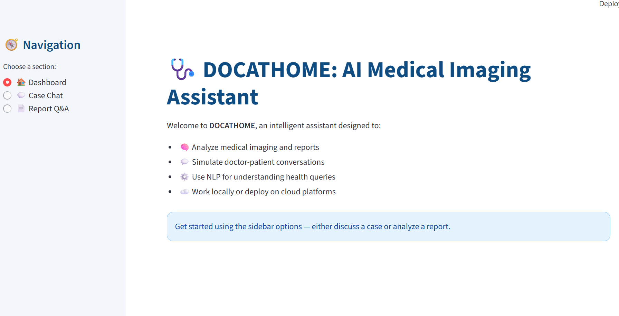

2
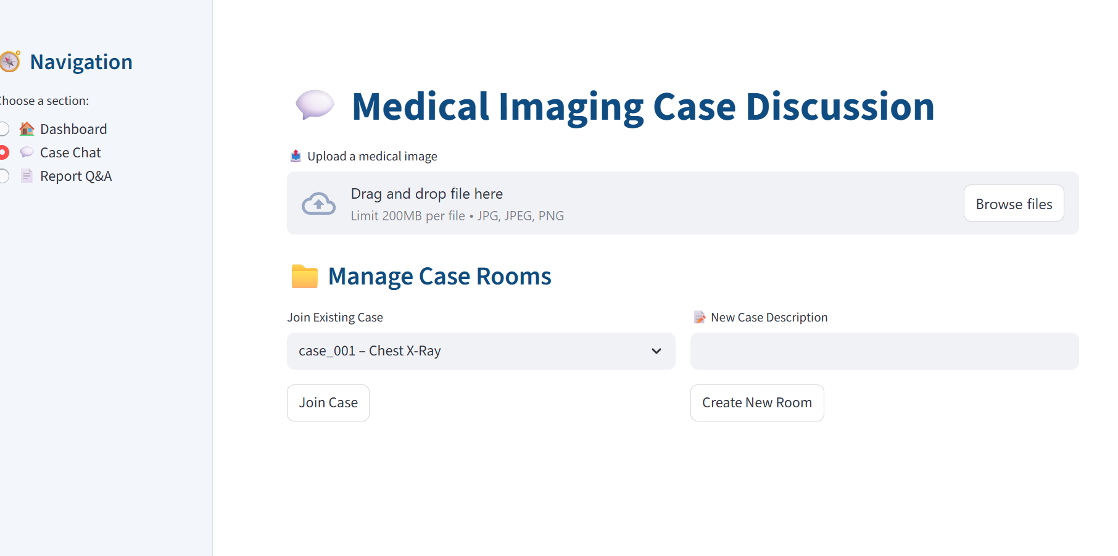

3

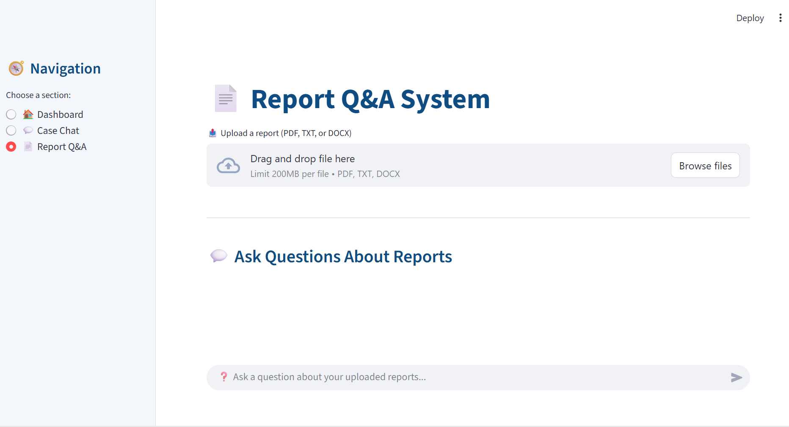

Conclusion and Future Scope

Conclusion
The Dr. AI Assistant successfully demonstrates how artificial intelligence can assist radiologists and healthcare professionals in delivering quick, accurate, and context-aware medical information.
By integrating a local transformer model (FLAN-T5) with an agentic architecture, the system ensures intelligent dialogue management, secure data handling, and completely offline functionality — overcoming common limitations like internet dependency and API quotas.
Through its Streamlit-based interface, the chatbot provides a smooth, real-time interaction experience, enabling doctors to query medical topics and receive concise, professional answers.
Overall, the project highlights the feasibility of cost-effective and privacy-preserving AI solutions for medical communication and education.

Future Scope
- Integration of Advanced Medical LLMs
Incorporate domain-specific AI models like BioGPT, MedPaLM, or Llama-Med for more accurate and detailed medical understanding.
- Image Analysis for Radiology Reports
Extend the system to analyze X-ray, CT, and MRI scans for automated interpretation and diagnostic support.
- Speech-Based Interaction
Implement voice recognition and text-to-speech modules for hands-free use by medical professionals.
- Knowledge Base Expansion
Connect to verified medical databases (like PubMed or WHO datasets) for real-time knowledge updates.
- Patient Data Integration
Allow linking with electronic health records (EHRs) for personalized, case-specific medical insights.
- Multilingual and Mobile Support
Deploy as a mobile application supporting multiple languages to reach wider healthcare communities.

Refrences

- https://www.kaggle.com/
- https://www.tensorflow.org/
- https://pandas.pydata.org/
- https://numpy.org/
- https://matplotlib.org/
- https://seaborn.pydata.org/
- https://www.tensorflow.org/tutorials

